Victor Phong's Eagle Project
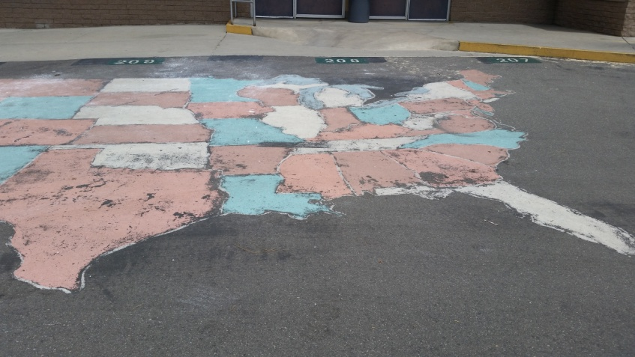
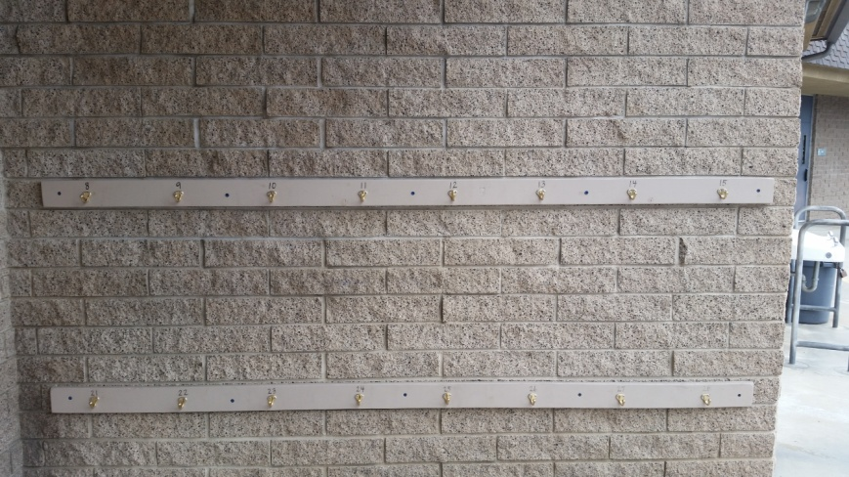

What:
- We will be creating backpack racks for 5 classrooms, 30 hooks each.
- We will also be painting two United States Maps onto the blacktop.
Where:
Gonsalves Elementary School - 13650 Park St, Cerritos, CA 90703 (Enter the school by the gates closest to the office.
When:
1st Day: Saturday, January 9th, 2016 from 8:00 AM to 5:35 PM
2nd Day: Saturday, January 23rd, 2016 from 8:00 AM to 2:00 PM
Stuff to bring:
*Bring work gloves (if you have them), sunscreen, full-brim hat, and shoes/clothes you wouldn't mind getting paint on.
*Breakfast, water, snacks, and lunch will be provided
Contact: victor_phong@yahoo.com or 562-404-5224

