Seeds of Hope Garden shed Project

Siddarth Mannava’s Eagle Project

Where: St. Andrew’s Episcopal Church
1231 E Chapman Ave Fullerton, CA 92831
When: Saturday, July 25th (8 AM to 5 PM)
Saturday, August 1st (8 AM to 5 PM)
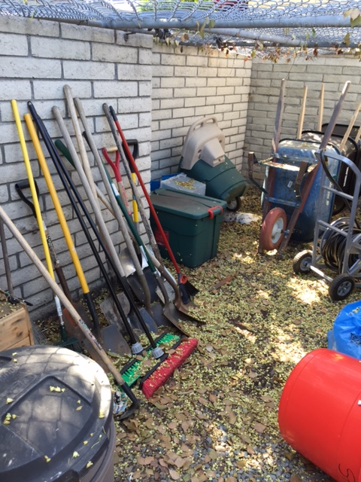
Project:
Day 1: Build two tool racks for the garden shed
Day 2: clean and organize the shed and install the tool racks
What to bring?
- Full brim hat
- Sunscreen
- Sunglasses
- Close toed shoes
- gloves

What to wear: Please wear clothes that can get dirty and full brim hat
Breakfast, Snack, Lunch, and Water will be provided
Contact:
Home Phone: (818) 264-5604
Siddarthm4@gmail.com

